Project Overview : 4
Election Flow : 4
Descriprion of project Real-Time Election Voting System : 5
Purpose and Scope: 5
Technological Stack: 5
Project Significance: 6
Expected Outcomes: 6
Description of data used 7
System Components: 8
Architectural of the project : 12
1. Architectural Foundations: Docker, Zookeeper, Kafka, and PostgreSQL 12
Docker: Containerization for Seamless Deployment 12
Zookeeper: Orchestrating Distributed Harmony 12
Kafka: Handling Real-Time Data Streams 12
PostgreSQL: Robust Relational Database Management 13
The Docker Compose file 13
Data Strategy and Schema Design with Python 15
Creating the Parties and Candidates : 15
Simulating the Pulse of Democracy 18
The Voting process 18
voting.py 19
voting process : 21
Harnessing Spark for Real-Time Data Alchemy 22
Live Streaming with Spark 22
spark-streaming.py 23
Visualizing Democracy in Action with Streamlit 25
Streamlit Live Visualisation Dashboard 25
streamlit-app.py 25
Final result 28
Statistique 29
Location of voters 30

Abstract

the project entails the development of a real-time voting system utilizing modern big data technologies such as Apache Kafka, Apache Spark, and Streamlit. The system is designed to facilitate the entire election process, from candidate and voter accreditation to the final declaration of the winner. Through a comprehensive architecture, data flows seamlessly from the accreditation phase to the voting process, where votes are streamed to Kafka and processed with PySpark for real-time analysis. The project culminates in a dynamic dashboard built with Streamlit, providing real-time insights into voting trends and results. This endeavor represents an innovative application of data engineering principles in the realm of election technology, showcasing the integration of various technologies to create a robust and efficient voting system.

Introduction

In the ever-evolving landscape of digital innovation, the imperative for real-time data processing has become indispensable across diverse domains. Among these, the domain of electronic voting systems stands at the forefront, demanding solutions that not only ensure the integrity of the democratic process but also enhance transparency and engagement. This project unfolds a comprehensive exploration into the development of a real-time election voting system, meticulously engineered to leverage cutting-edge technologies.
At the heart of this endeavor is a robust architecture that harmonizes Docker, Kafka, PostgreSQL, Python, Apache Spark, and Streamlit. These technologies collectively converge to construct a dynamic, scalable, and transparent platform that transcends traditional election paradigms. The project simulates the intricacies of a live election, where votes are cast, processed, and visualized in real-time, presenting an innovative departure from the conventional model of awaiting finalized results.
The architectural foundation, established through Docker, orchestrates the seamless interaction of critical components like Zookeeper, Kafka, and PostgreSQL. Each component plays a distinctive role in ensuring the stability, scalability, and persistence of the system. As votes are cast, the system's pulse is simulated by Python scripts, creating a dynamic voting process that mirrors the vibrancy of a live election.
The data strategy employed in this project is not merely a technical formality; it is a meticulous design crafted by Python scripts to define the schema of the PostgreSQL database. Realistic voter data, sourced from the randomuser API, adds authenticity to the system, underscoring the importance of a well-thought-out data strategy.
The heart of the democratic process is encapsulated in the voting.py script, illustrating the seamless flow of information through Kafka, the backbone of this real-time system. Here, Kafka's prowess in handling high-throughput data streams is demonstrated as each vote contributes to the unfolding narrative of the election in real-time.
As the project navigates through the realms of data alchemy, Apache Spark takes the center stage through the spark-streaming.py script. This script transforms raw data streams into meaningful insights, showcasing Spark's exceptional capabilities in real-time data processing. The project culminates in the Streamlit application, offering an interactive window into the heart of the election system. Here, aggregated data is brought to life through dynamic visualizations, making the democratic process not just transparent but also engaging.
In conclusion, this project exemplifies a synthesis of advanced technologies in redefining the dynamics of electoral processes. From the foundational architecture to the visualization of real-time results, each facet of the project unfolds as a testament to the transformative power of technology in fostering transparent, engaging, and dynamic democratic experiences.

Project Overview :
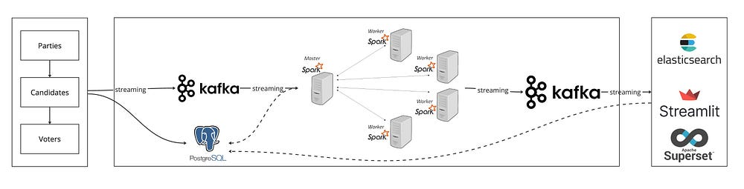
the system architecture :
Our project simulates a real-world election scenario where votes are cast, processed, and visualized in real-time. We’ll set up architecture using Docker to manage our components:
- Zookeeper & Kafka for real-time data streaming.
- PostgreSQL for data persistence.
- Python scripts for data generation and processing.
- Apache Spark for stream processing.
- Streamlit for live data visualization.

Election Flow :

Similar to traditional way of electoral voting; we have parties in our case . In our real-time election voting setup, we’ve got something similar to traditional voting with parties like the Management Party, Savior Party, and Tech Republic Party. But, here’s where it gets different and exciting: instead of waiting for the final count, our system shows you the voting results as they happen. You can actually see the votes rolling in for each candidate. It’s like watching a live race where each candidate is moving ahead or falling behind based on real-time votes. This way, you get a clear, up-to-the-minute picture of how the election is unfolding, making the whole voting experience more engaging and transparent.

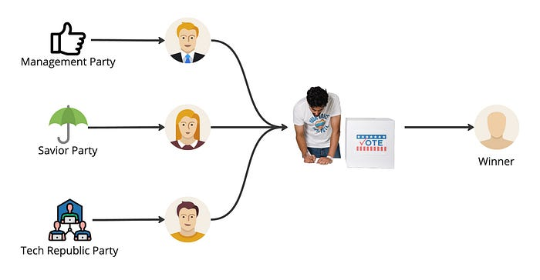

Descriprion of project Real-Time Election Voting System :

This project is a detailed exploration and implementation of a real-time election voting system, showcasing robust data engineering practices. The system leverages state-of-the-art technologies, including Docker, Kafka, PostgreSQL, Python, Apache Spark, and Streamlit, to create a dynamic and responsive platform for conducting elections.

Purpose and Scope:

The primary objective is to design and develop a voting system that operates in real-time, providing instantaneous updates on voting activities and results.
The scope encompasses the entire data engineering process, from data generation and processing to real-time analytics and visualization.

Technological Stack:

- Utilization of Docker for containerization, ensuring seamless deployment and scalability of system components.
- Integration of Kafka for efficient and reliable real-time data streaming, handling the influx of voting data with speed and precision.
- Adoption of PostgreSQL for data persistence, ensuring the secure storage of crucial voting information.
- Implementation of Python scripts for data generation, processing, and initial setup, contributing to the overall functionality of the system.
- Harnessing the power of Apache Spark for stream processing, enabling real-time data analytics and insights.

Key Components:

Docker: Orchestrates the deployment of essential components, including Zookeeper, Kafka, PostgreSQL, and Spark, ensuring a cohesive and manageable system architecture.

Kafka: Facilitates real-time data streaming, handling the flow of voting data from the generation phase through to processing and analysis.

PostgreSQL: Serves as the backbone for data persistence, securely storing voter information and election-related data.

Python Scripts: Responsible for data generation, initial setup, and schema design in PostgreSQL, forming a crucial part of the data engineering pipeline.

Apache Spark: Empowers the system with real-time data processing capabilities, allowing for live aggregations and analytics.

Project Significance:

The project addresses the need for transparency and immediacy in the electoral process, providing voters and stakeholders with real-time updates on voting trends and outcomes.
It showcases the integration of diverse technologies to create a seamless and efficient data pipeline for handling election-related data.

Expected Outcomes:

A fully functional and scalable real-time election voting system capable of handling large-scale voting events.
Real-time visualization of voting results, providing a transparent and engaging experience for users.

In summary, the Real-Time Election Voting System project aims to revolutionize the traditional election process by introducing modern technologies that enable real-time data processing, analytics, and visualization.

Description of data used

The API utilized in the system for generating candidate and voter data is the Random User API. This API provides randomly generated user data, including information such as names, email addresses, phone numbers, addresses, and even profile pictures. The data generated by this API closely resembles real user data and can be customized based on parameters provided in the API request.
In the context of the voting system, this API is used to create realistic candidate profiles and voter identities. For candidates, the generated data can include attributes such as name, party affiliation, biography, and campaign platform. For voters, the generated data typically includes demographic information such as age, gender, and location.
By using the Random User API, the system can populate its database with a diverse set of fictional candidates and voters, ensuring a realistic simulation of the electoral process. This allows for testing and development of the voting system in a controlled environment before it is deployed for real-world use.
The Random User API is a service that provides randomly generated user data, which closely resembles real user information. Here's a breakdown of the types of data that can be obtained from the API:

Name: The API can generate random names for candidates and voters, including first names and last names.

Email Address: Randomly generated email addresses are provided, which can be used to uniquely identify each candidate and voter within the system.

Phone Number: The API can generate phone numbers associated with each user, adding further realism to their profiles.

Address: Random addresses, including street addresses, cities, states, and postal codes, are provided. This can simulate the geographic distribution of candidates and voters.

Profile Picture: The API offers profile pictures for users, which can enhance the visual representation of candidates and voters within the system.

Additional Information: Depending on the specific requirements of the system, additional data such as age, gender, nationality, and other demographic details can also be generated.

System Components:

main.py: This Python script serves as the central component, responsible for creating essential tables on PostgreSQL (candidates, voters, and votes). Additionally, it orchestrates the setup of a Kafka topic and replicates the votes table within it. Furthermore, it encapsulates the logic for consuming votes from the Kafka topic and producing data to the voters_topic on Kafka.
voting.py: This Python script is dedicated to consuming votes from the Kafka topic (voters_topic), generating voting data, and subsequently producing data to the votes_topic on Kafka.
spark-streaming.py: This Python script encompasses the logic for consuming votes from the Kafka topic (votes_topic), enriching the data retrieved from PostgreSQL, aggregating the votes, and ultimately producing data to specific topics on Kafka.
streamlit-app.py: This Python script is responsible for consuming aggregated voting data from the Kafka topic, as well as from PostgreSQL. It facilitates the real-time display of voting data using Streamlit.
Setting up the System: The provided Docker Compose file streamlines the deployment of Zookkeeper, Kafka, and Postgres applications within Docker containers.
Prerequisites:
Python 3.9 or a newer version installed on your system.
Docker Compose installed.
Docker installed.
Steps to Run:
Navigate to the directory containing the Docker Compose file.
Execute the following command:

docker-compose up -d

This command initializes Zookeeper, Kafka, and Postgres containers in detached mode (-d flag). Kafka will be accessible at localhost:9092, and Postgres at localhost:5432.
Additional Configuration: If adjustments to Zookeeper configurations or exposed ports are necessary, you can modify the docker-compose.yml file to accommodate your requirements.
Running the App:
Install the requisite Python packages using the following command:
pip install -r requirements.txt
This is the result :
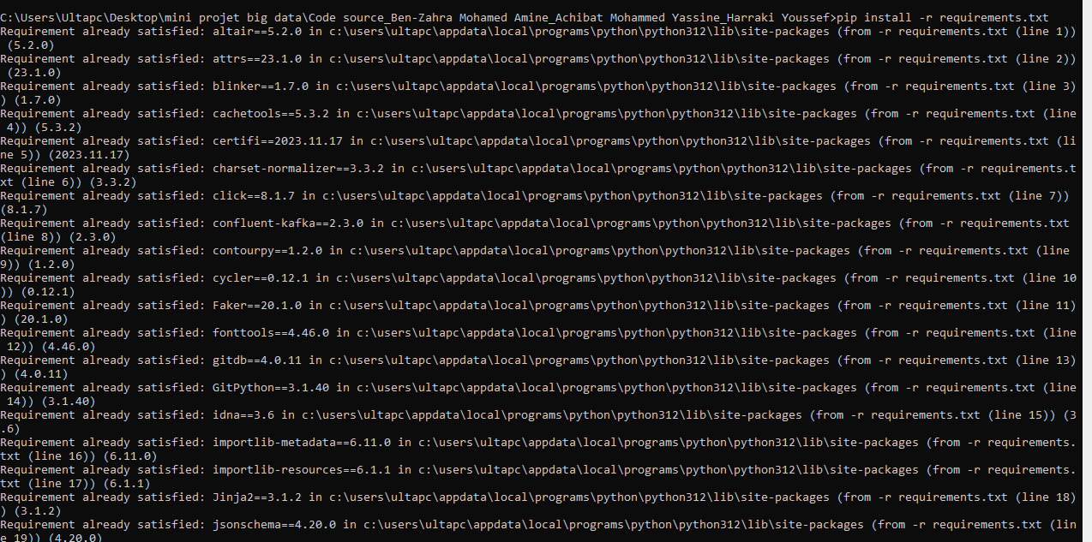

Execute python main.py to create the necessary tables on PostgreSQL and generate voter information on the Kafka topic.
This is the result :
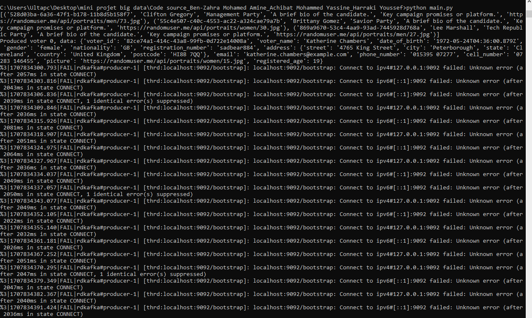
Run python voting.py to consume voter information from the Kafka topic, generate voting data, and produce data to the Kafka topic.
This is the result :
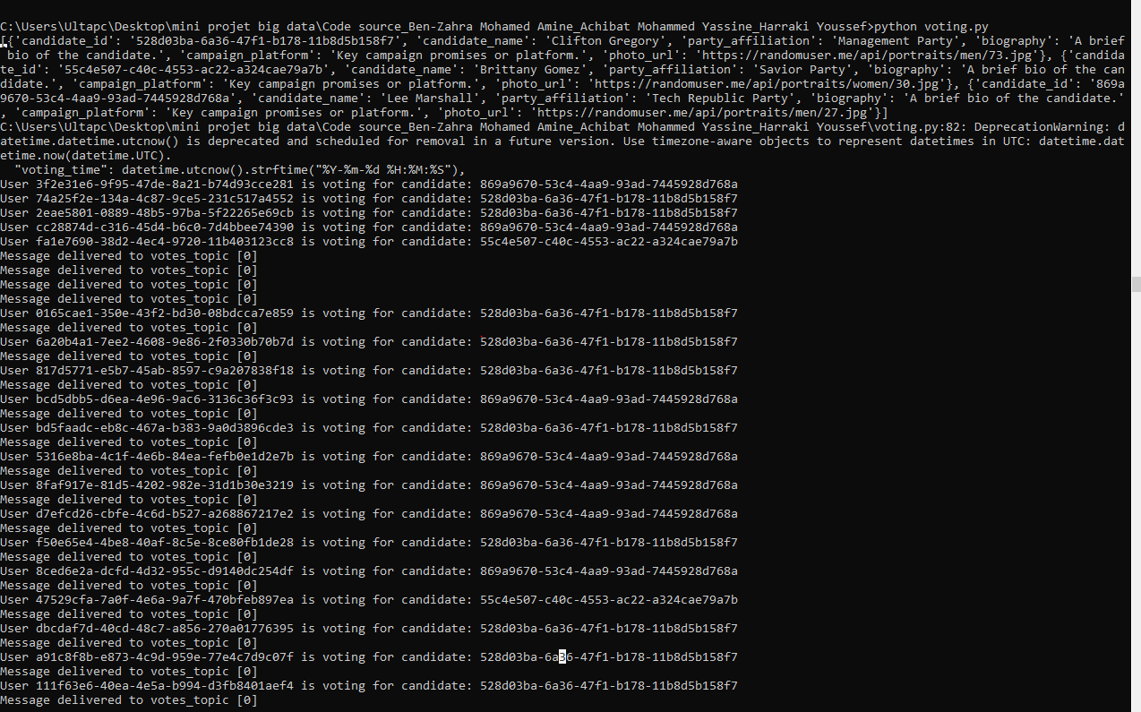
Execute python spark-streaming.py to consume voting data from the Kafka topic, enrich the data from PostgreSQL, and produce data to specific Kafka topics.
This is the result :
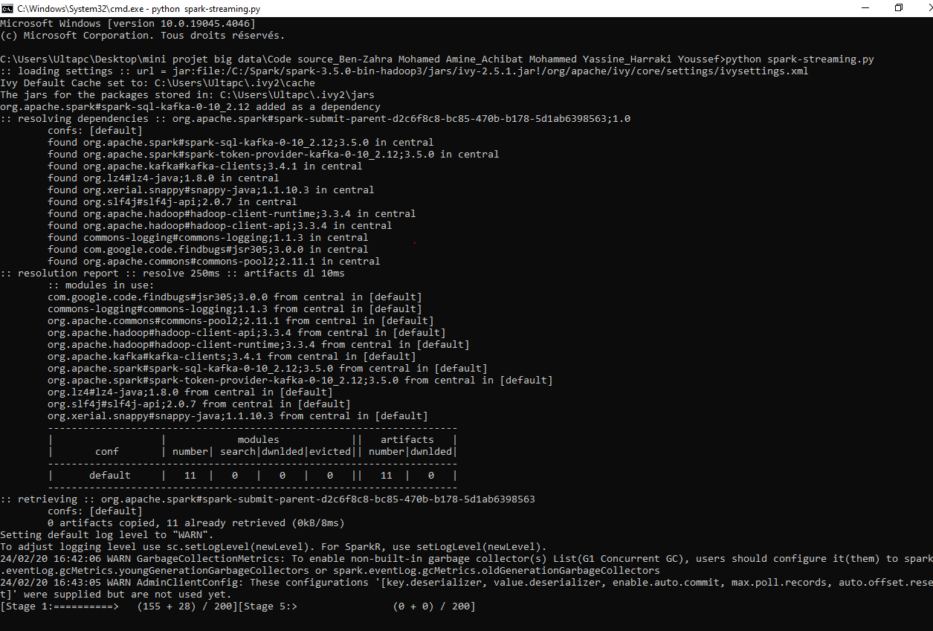
Launch the Streamlit app by running:
streamlit run streamlit-app.py
This is the result of command line :

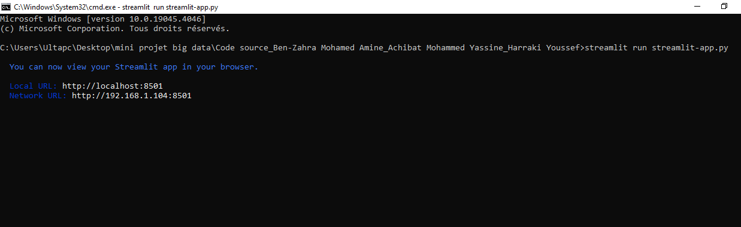

Architectural of the project :

1. Architectural Foundations: Docker, Zookeeper, Kafka, and PostgreSQL

Docker: Containerization for Seamless Deployment

Docker, a powerful containerization platform, serves as the cornerstone of the project's architectural foundation. Containers encapsulate applications and their dependencies, ensuring consistency across various environments. Docker simplifies deployment, enhancing the project's portability and scalability. With the provided Docker Compose file, the orchestration of vital components becomes a streamlined process.

Zookeeper: Orchestrating Distributed Harmony

Zookeeper, a distributed coordination service, plays a pivotal role in maintaining synchronization among distributed components. It ensures a coherent and fault-tolerant interaction between various services. In our architecture, Zookeeper acts as the orchestral conductor, ensuring the harmony and coordination required for the smooth operation of Kafka, the distributed streaming platform.

Kafka: Handling Real-Time Data Streams

Apache Kafka, the heart of the real-time data processing, excels at managing high-throughput data streams. In this architecture, Kafka operates as a distributed messaging backbone, facilitating the seamless flow of real-time voting data. The publish-subscribe model employed by Kafka ensures fault tolerance, scalability, and durability – crucial elements for handling the dynamic nature of election data.

PostgreSQL: Robust Relational Database Management

PostgreSQL, a robust and extensible relational database management system, serves as the repository for crucial data. This includes voter details and election results. PostgreSQL's ACID-compliance guarantees the integrity of the stored data. As an integral part of the system's architecture, PostgreSQL ensures persistent and reliable storage for essential information throughout the election process.

In essence, the architectural foundation of Docker, Zookeeper, Kafka, and PostgreSQL forms a well-integrated and robust framework. Docker provides flexibility and consistency in deployment, Zookeeper ensures distributed coordination, Kafka manages the dynamic data streams, and PostgreSQL acts as the secure repository for persistent data storage. This synergy establishes the resilience and scalability required for the real-time election voting system.

The Docker Compose file

This docker compose file helps you spin up Zookeeper, Kafka, Postgres and Spark master-worker architecture.

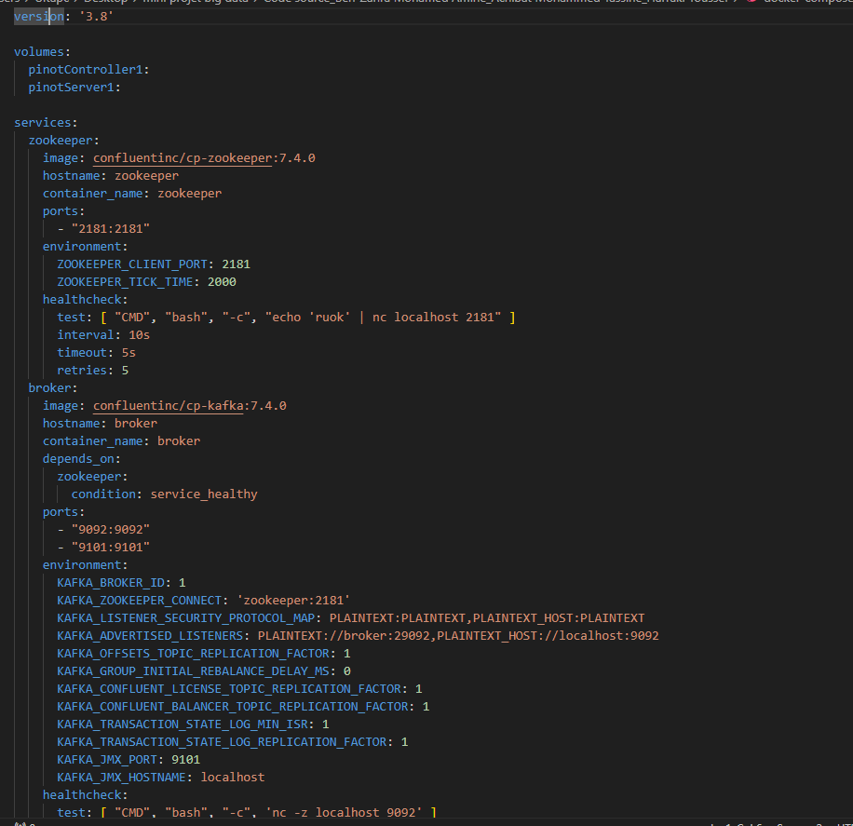

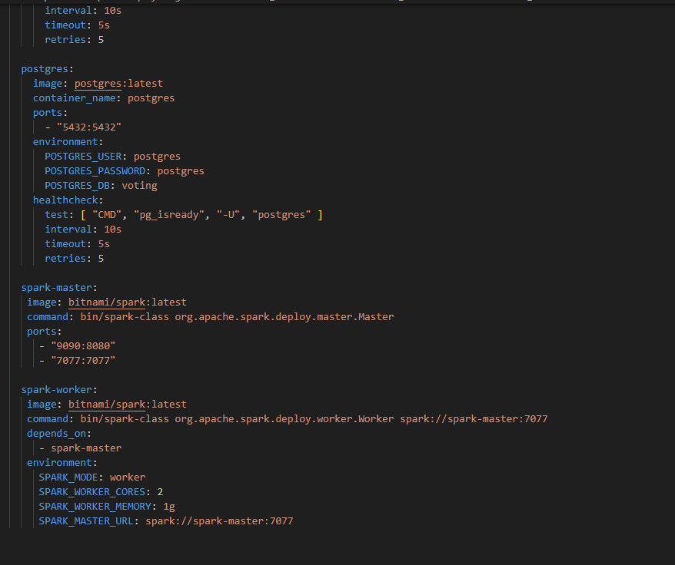

You can fire up the system architecture by running the command below:
docker compose up -d

Data Strategy and Schema Design with Python

Here, we delve into the intricacies of data preparation. Our main.py script is not just a tool; it's the artisan that meticulously crafts the database schema in PostgreSQL and populates it with the voters' information. This phase is crucial - it's where we lay down the blueprint of our data structure, ensuring that each piece of information is precisely where it needs to be. We'll unravel the logic behind our schema design and data generation, showcasing how a well-thought-out data strategy is pivotal for the system's success. The users information are gotten from randomuser api.

Creating the Parties and Candidates :

The parties and the candidates are setup in the main.py file. We have 3 static parties, Management Party , Savior Party and Tech Republic Party . It is assumed each of these parties already gone through the initial primaries to select their final candidates for the election.
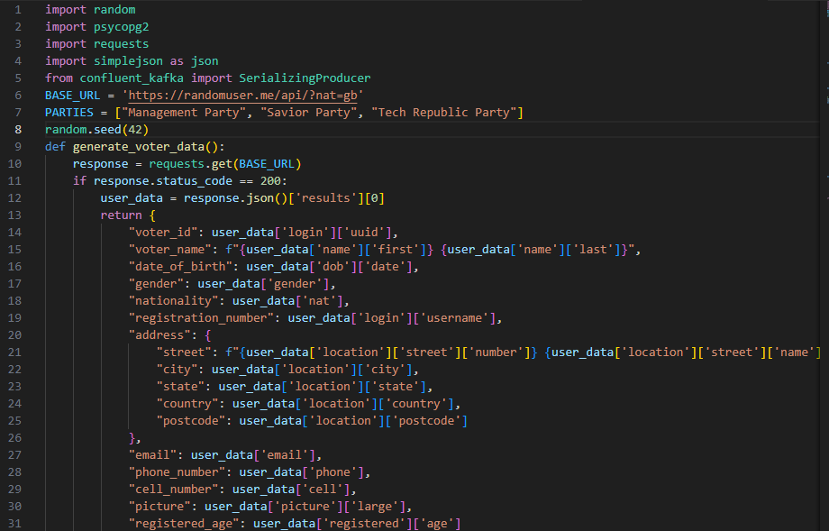
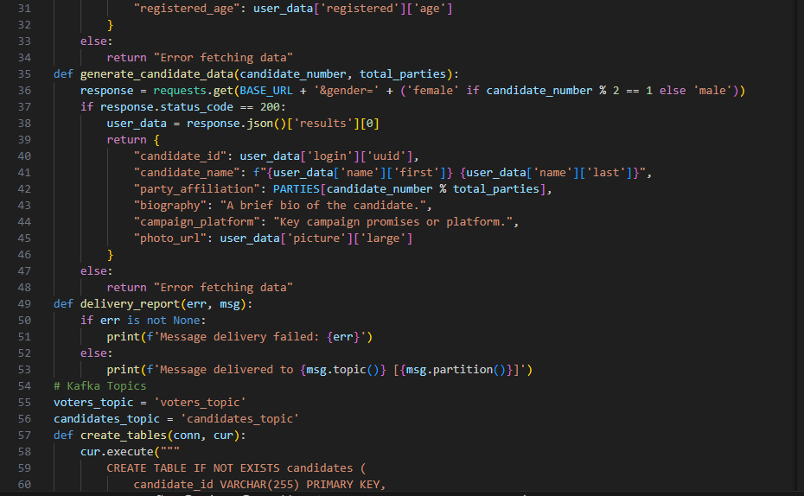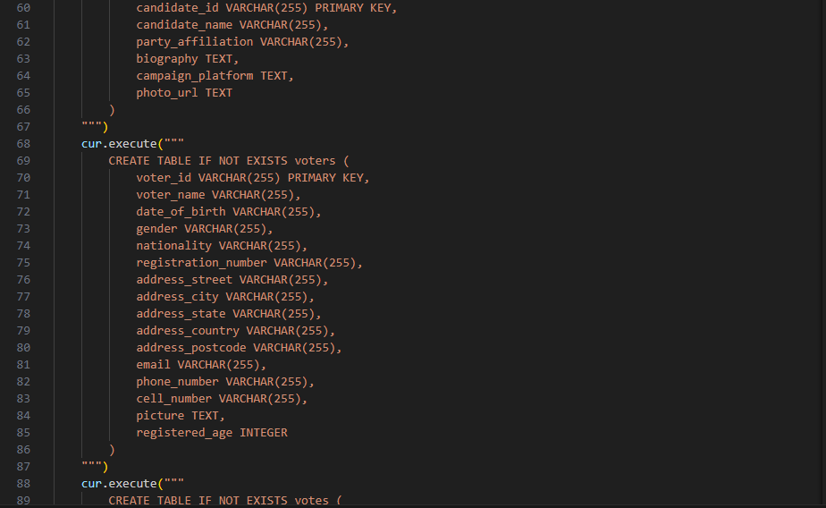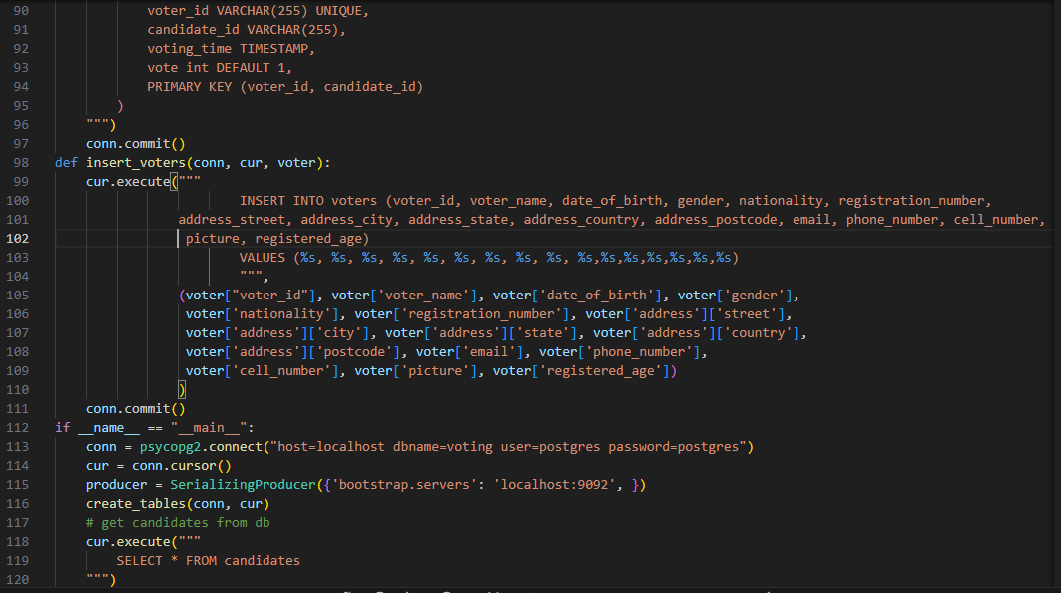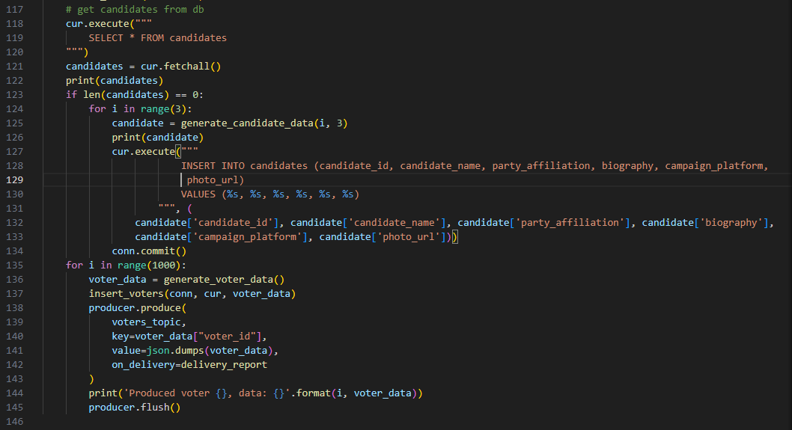

Once the main.py is running the candidates and their respective parties will be created in PostgresSQL and the voters information will be produced into Kafka.
Parties and candidates information can be verified on PostgreSQL by connecting postgres with:
psql -U postgres -d voting
select * from candidate;

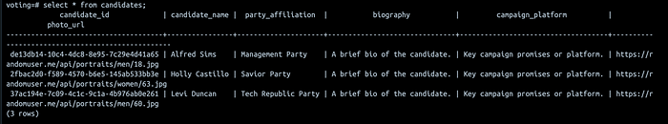

parties and candidates information
You can also verify the voters information as well by running the command below and you should be presented with the records inserted into the voters table.
select * from voters
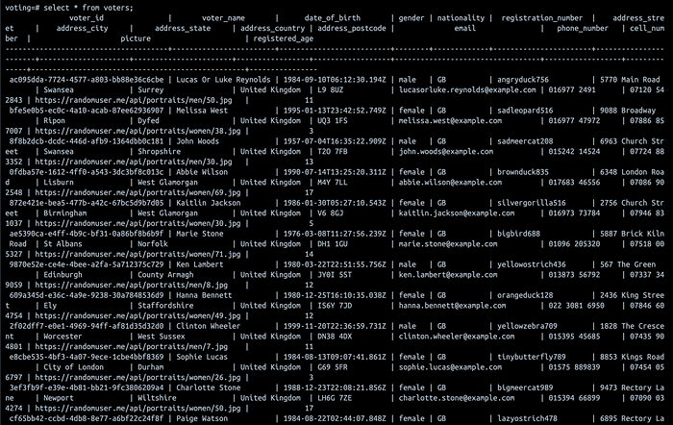

voters information

Simulating the Pulse of Democracy

The Voting Process: The voting.py script is where the magic happens. It's the heartbeat of our system, simulating the voting process. Each vote, encapsulated in a burst of data, is sent to a Kafka topic, demonstrating Kafka's prowess in handling real-time data streams. This is where we witness the seamless flow of information, a testament to Kafka's efficiency and our system's capability to mimic the real-world voting rhythm.

The Voting process
The voting process is where the selection happens, each of the voters selects a candidate to vote for. This is done by subscribing to the voters_topic on kafka and for each of the voters information consumed, a copy of the candidate information is randomly picked and a vote json is generated and produced into a kafka topic.

voting.py
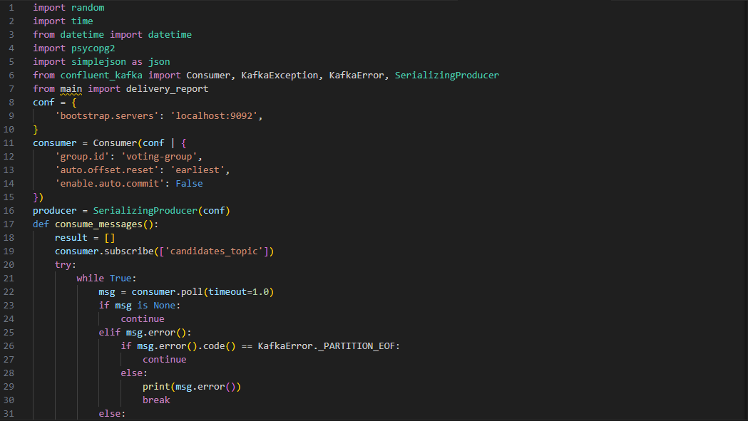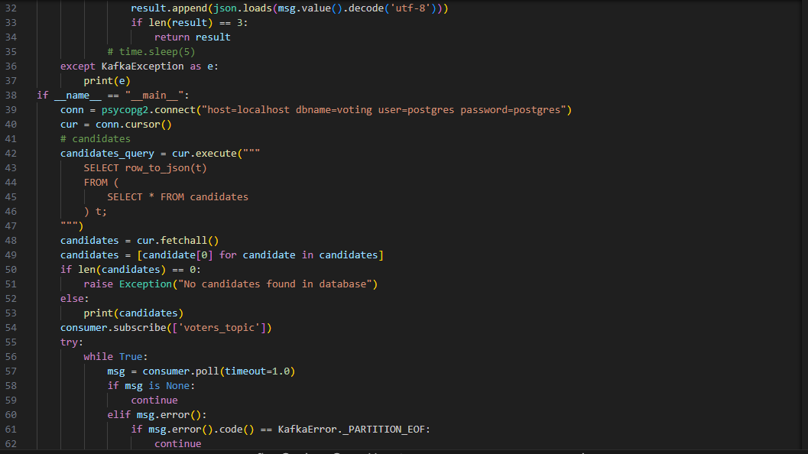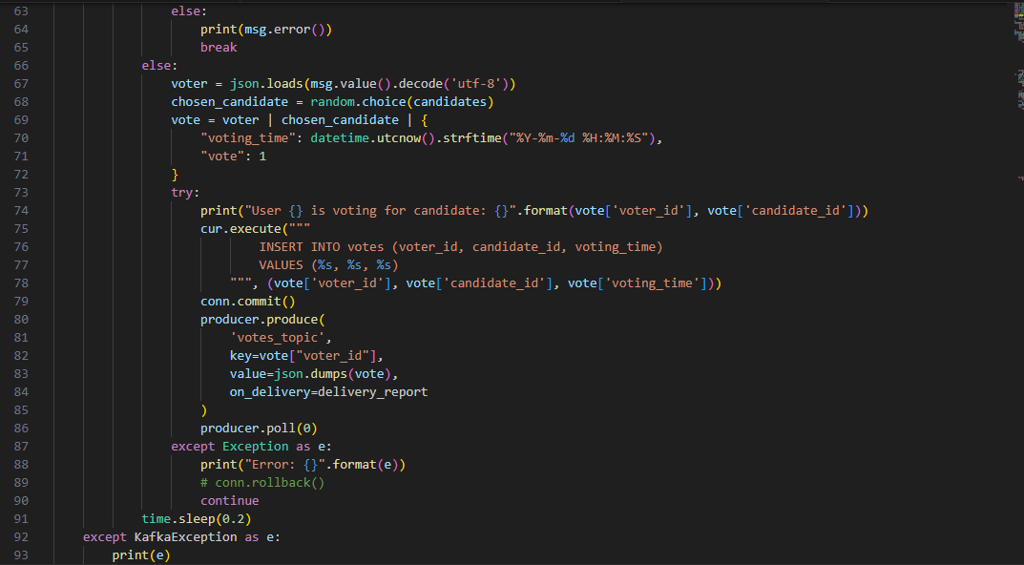

When you run this with python voting.py your should see an output like this;
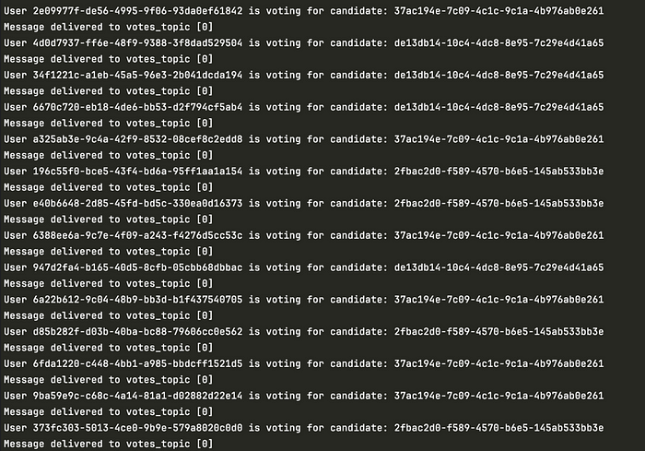

voting process :

On the voters_topic , each of the records produced can be visualised in kafka topic by running the commands below. To view the list of topics on the Kafka broker (this command should be ran on the broker docker container):
kafka-topics --list --bootstrap-server broker:9092
To consume the data produced to the voters_topic; the --from-begining is used to consume data from the initial offset on the topic. If you want to consume only the latest data produced to the topic, you don’t need to add the flag to the command.
kafka-console-consumer --topic voters_topic --bootstrap-server broker:9092 –from-beginning

The output should look like somewhat like this:
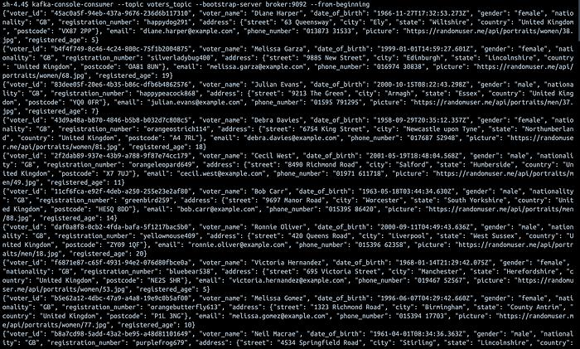
consuming data from the voters_topic from the beginning

Harnessing Spark for Real-Time Data Alchemy

With spark-streaming.py, we enter the realm of real-time data processing. This script is the alchemist that transforms raw data streams into meaningful insights. Consuming data from Kafka, it performs live aggregations, morphing streams into valuable information, and then circulates this refined data back into Kafka. This segment will illuminate Spark's extraordinary abilities in stream processing and real-time analytics, showcasing how it turns data into gold.

Live Streaming with Spark

The dependencies for the Spark streaming can be resolved by first knowing the spark version installed on your machine this can be verified by running print(pyspark.__version__). On my machine, I have version 3.5.0 and that’s why all the dependencies I have are 3.5.0 dependencies. You can get the dependency information in the maven repository. As for the PostgreSQL driver, that can be downloaded on the postgres JDBC download page.

spark-streaming.py

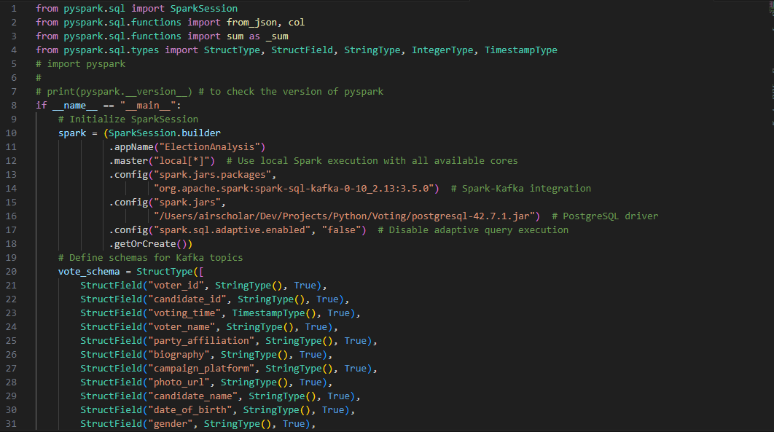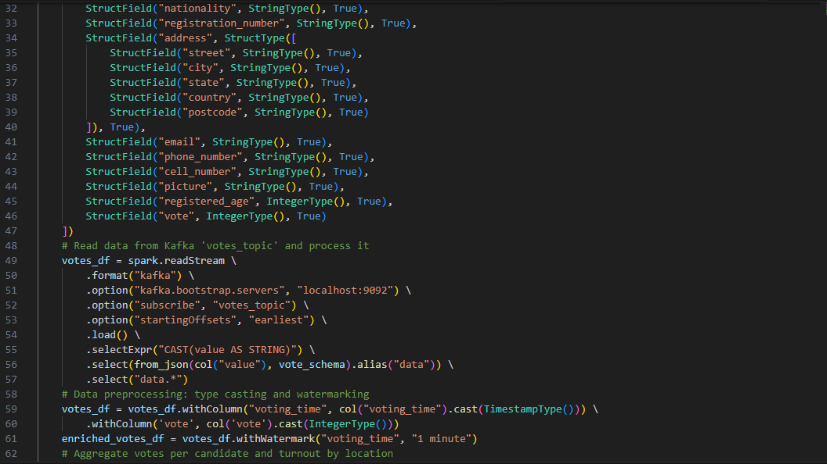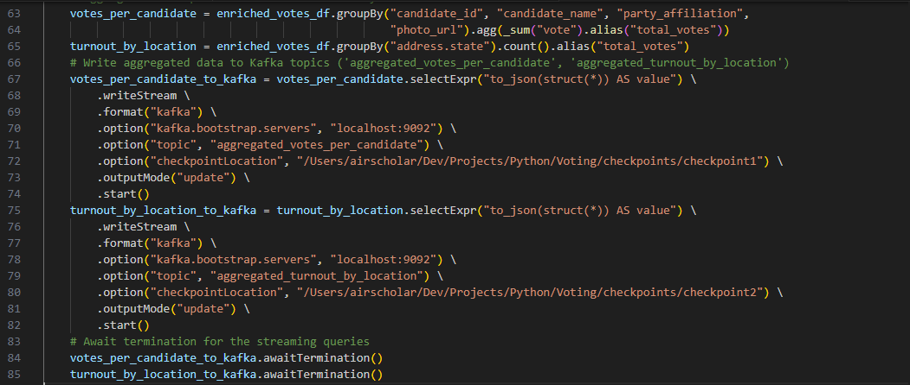
You can run this by running python spark-streaming.py or by submitting the job to the spark cluster for more compute with:
spark-submit --master spark://localhost:7077 spark-streaming.py

Visualizing Democracy in Action with Streamlit

The final act of our symphony is the Streamlit app, a window into the heart of our election system. This is where data comes to life, transformed into vivid, dynamic visualizations. We’ll explore how this app draws from the aggregated data in Kafka, turning numbers and statistics into compelling, real-time visual narratives. This is where the abstract becomes tangible, where bytes and data points crystallize into clear, understandable insights.

Streamlit Live Visualisation Dashboard

In this section, we are going to be consuming data from the kafka topics containing the aggregated votes of the candidates, the party information, their pictures as well the location of the voters.

streamlit-app.py

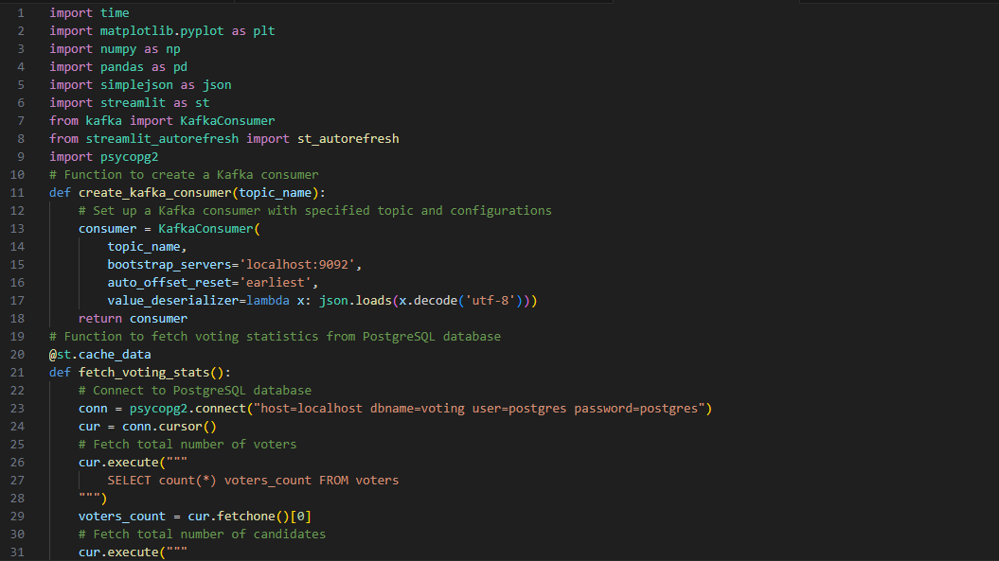
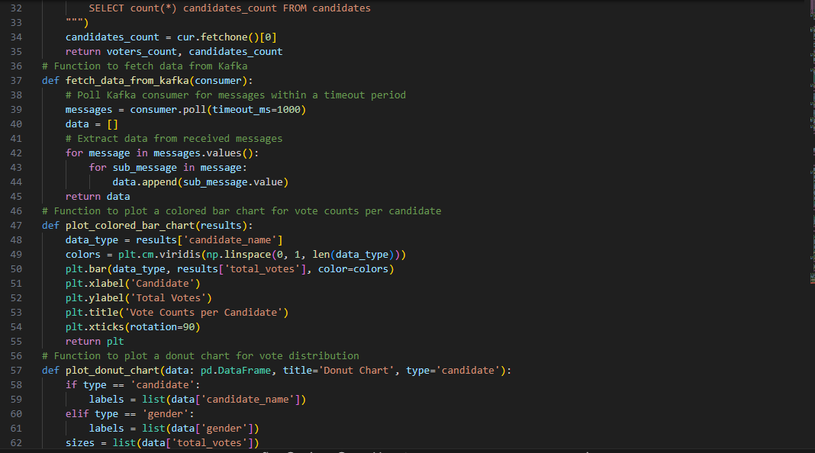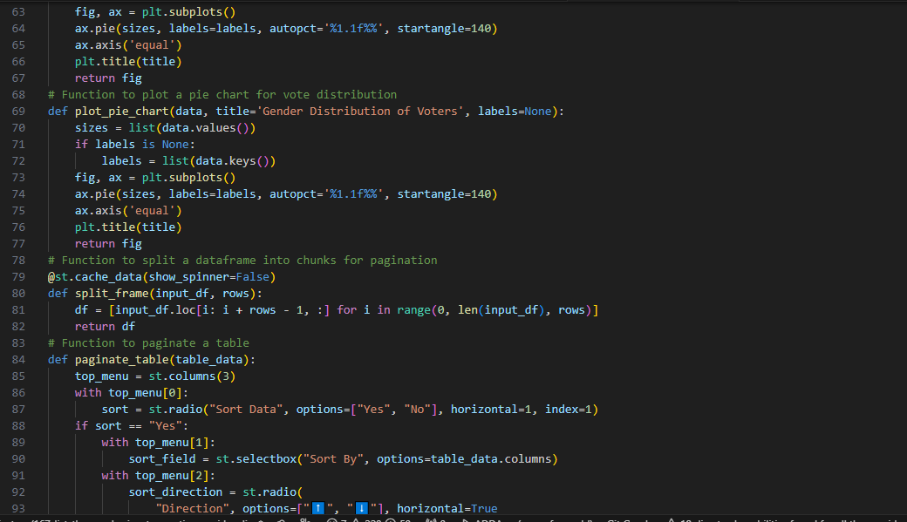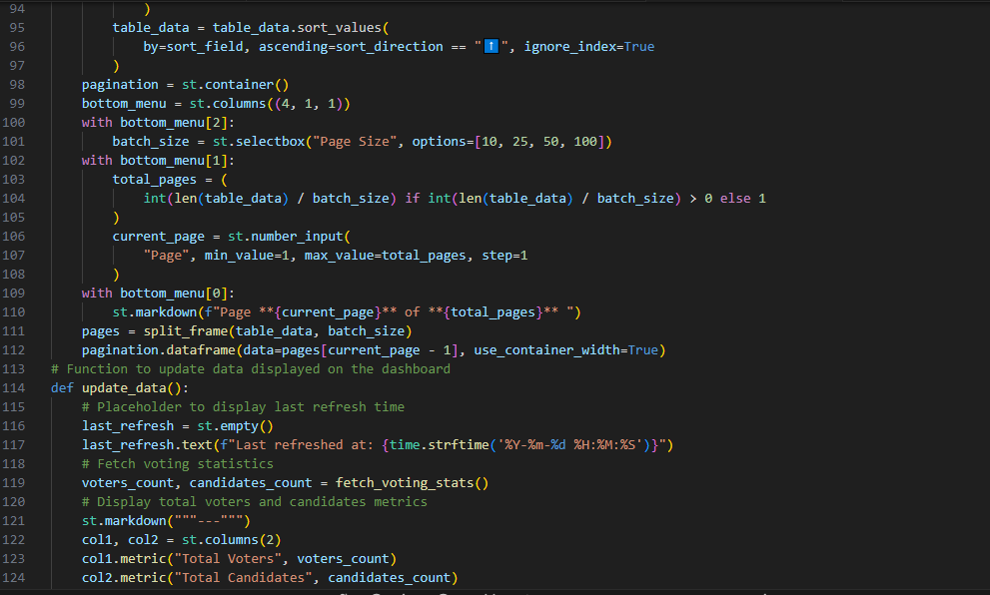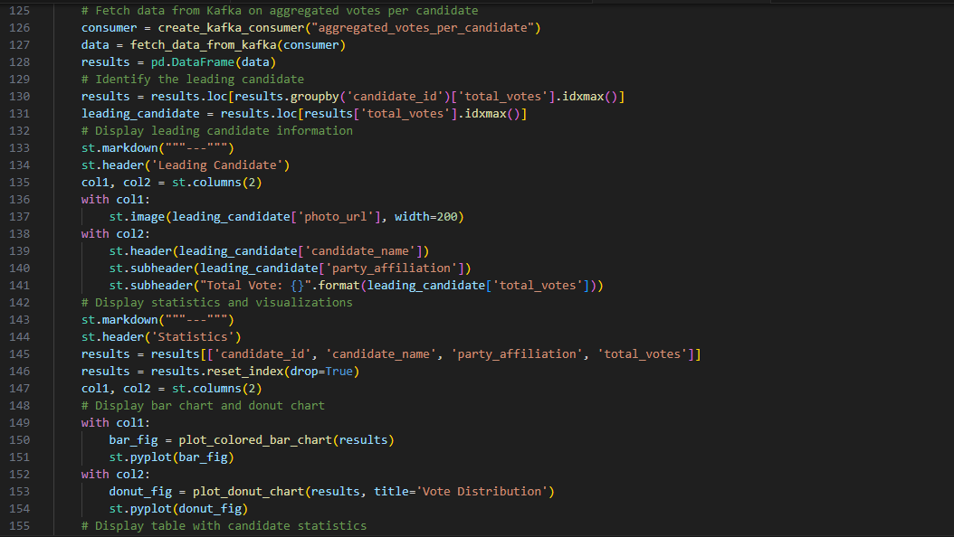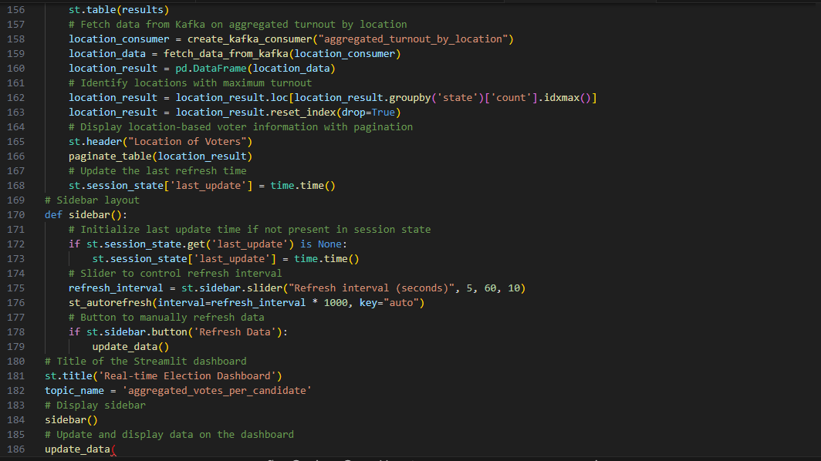

Final result

You can trigger a run of the dashboard by running the command below:
streamlit run streamlit-app.py
And you should have the a page launched with the dashboard below, auto refreshing every 10 seconds (this can be adjusted at the sidebar by increasing/decreasing the slider data).

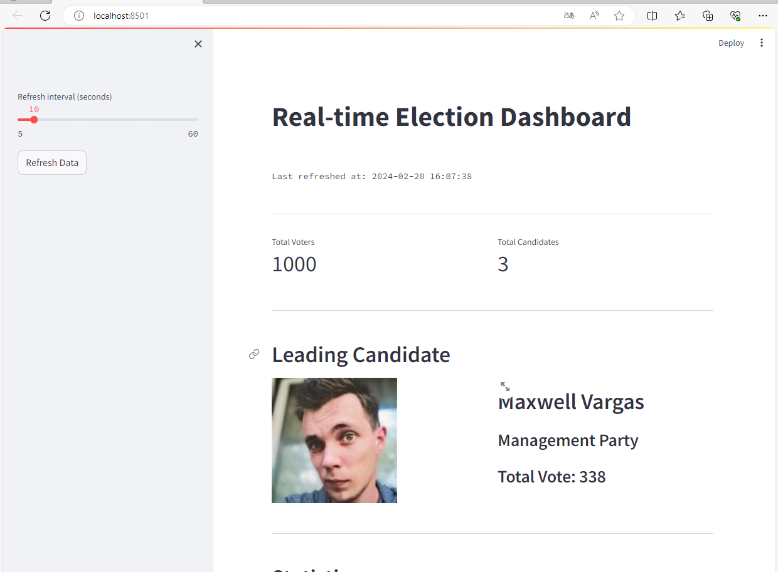

Statistique

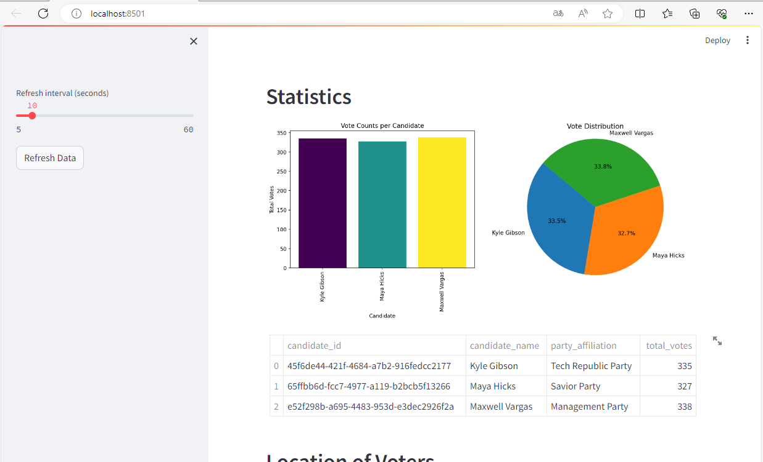

Location of voters

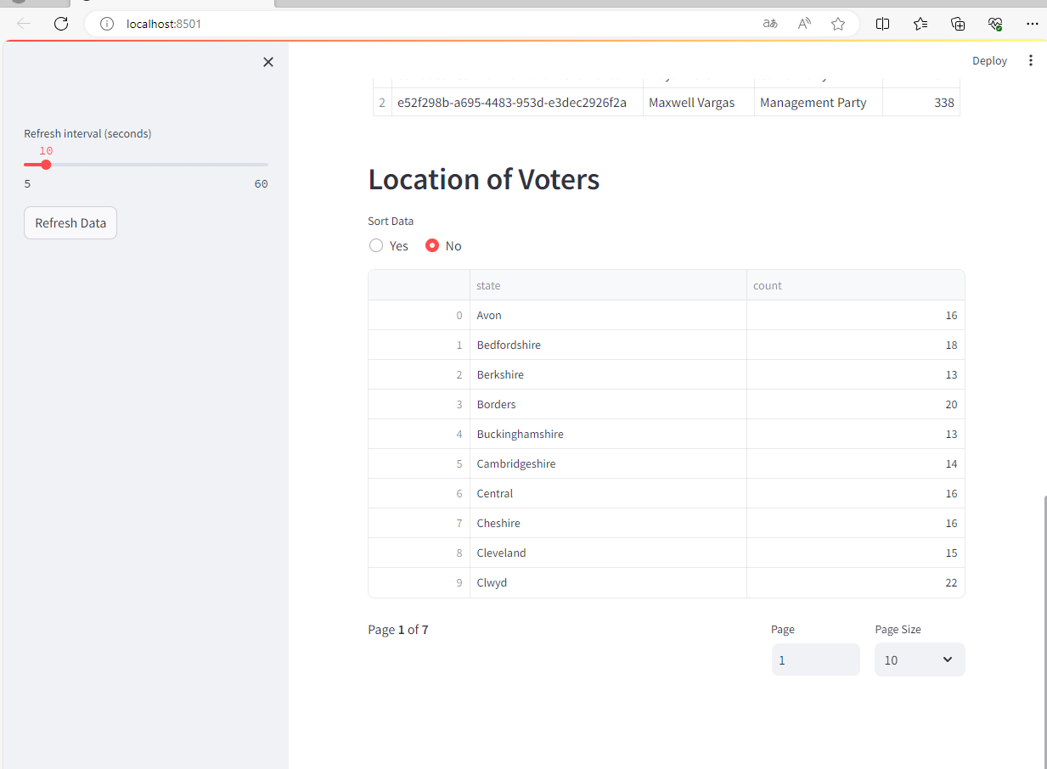

Conclusion:

In the rapidly evolving landscape of digital solutions, the Real-Time Election Voting System stands as a testament to the power of modern data engineering technologies in transforming traditional processes. The comprehensive exploration and implementation of this project reveal several key insights and implications.

Transparency and Engagement:
The project addresses a fundamental aspect of democratic processes – transparency. By providing real-time updates on voting activities and results, the system enhances the level of transparency in elections, fostering trust among voters and stakeholders.
The engagement factor is significantly heightened as voters can actively witness the evolving election scenario, akin to watching a live event. This dynamic approach redefines the traditional static nature of elections, making the entire process more participative.

Technology Integration:
The seamless integration of Docker, Kafka, PostgreSQL, Python, Apache Spark, and Streamlit showcases the potential of a well-curated technological stack. Each component plays a crucial role in creating a harmonious and efficient system architecture, ensuring the reliability and scalability of the platform.

Real-Time Data Processing:
One of the project's highlights is the incorporation of real-time data processing through technologies like Kafka and Apache Spark. This capability not only revolutionizes the speed at which voting data is handled but also opens avenues for live analytics and insights, providing a deeper understanding of the election dynamics.

User-Centric Visualization:
The inclusion of the Streamlit application serves as the bridge between raw data and user understanding. By transforming aggregated data into dynamic visualizations, the system ensures that complex information becomes accessible, allowing users to make informed interpretations of the ongoing election.

Scalability and Adaptability:
The Docker-based architecture not only simplifies deployment but also enhances the system's scalability. As election events may vary in scale, the adaptability of the system becomes a crucial factor, ensuring it can seamlessly handle both small and large-scale voting scenarios.

Educational Value:
Beyond its immediate application, the project holds educational value by providing a comprehensive example of end-to-end data engineering. It serves as a learning resource for individuals and professionals interested in understanding how various technologies can be orchestrated to solve complex, real-world problems.

Room for Future Enhancements:
The project, while comprehensive, leaves room for future enhancements and refinements. This includes the incorporation of additional security measures, integration with external systems, and exploration of machine learning techniques for predictive analytics.

In conclusion, the Real-Time Election Voting System not only represents a technological feat in data engineering but also a paradigm shift in the way we perceive and conduct elections. By embracing real-time capabilities, transparency, and user engagement, this project sets a standard for leveraging technology to enhance democratic processes in the digital age.

REFRENCES

Apache Kafka:

Official Website: http://kafka.apache.org/
Documentation: http://kafka.apache.org/documentation/
GitHub Repository: https://github.com/apache/kafka

Apache Spark:

Official Website: http://spark.apache.org/
Documentation: http://spark.apache.org/docs/latest/
GitHub Repository: https://github.com/apache/spark

Streamlit:

Official Website: https://streamlit.io/
Documentation: https://docs.streamlit.io/
GitHub Repository: https://github.com/streamlit/streamlit

Docker:

Official Website: https://www.docker.com/
Documentation: https://docs.docker.com/
GitHub Repository: https://github.com/docker/docker-ce

PySpark:

Official Website: http://spark.apache.org/docs/latest/api/python/index.html
Documentation: http://spark.apache.org/docs/latest/api/python/index.html
GitHub Repository: https://github.com/apache/spark/tree/master
/python/pyspark

Docker Compose:

Official Website: https://docs.docker.com/compose/
Documentation: https://docs.docker.com/compose/
GitHub Repository: https://github.com/docker/compose

Medium Article:

Medium: https://medium.com/

Data Mastery Lab:

Website: https://datamasterylab.com/

